MORDEN

and other Tourist Destinations

Amy Deakin

Published by William Cornelius Harris Publishing

In collaboration

with

London Poetry Books

Supporting Mental Health in Performing Arts

ISBN 978-1-911232-09-4

Copyright © Amy Deakin 2017

All rights reserved

c/o Open Door, 224 Jamaica Road, London SE16

London Poetry Books

[www.londonpoetrybooks.com](http://www.londonpoetrybooks.com)

**Dedication**

This book is dedicated to my hometown Morden, a place to go to get to other places, but not a place to go.

It is also dedicated to my family, who, despite my best efforts, continue to put up with me.

**Acknowledgements**

In this book I quote and make reference to Merton Council’s website, Ed Miliband, the Bible and travel writer Paul Thereoux. *The Tourist’s Guide to Morden* sadly does not exist, but if it did, I’m sure many fellow travellers to South West London would find it enlightening.

Artwork is credited to Jane Deakin, fine artist and fellow member of the Deakin clan. Jane studied Fine Art at Reading University. Her work is based on nature through which she expresses the romanticism of natural beauty in the form of abstract painting. Jane is based in Rotherhithe, South East London and her work can be found at [www.bridgemanimages.com](https://www.bridgemanimages.com/en-US/studio/artist/6824/gallery).

**EXTRACT ONLY**

**Contents**

**Places of interest** 5

Morden 7

The poets’ garden 9

When aliens landed in Lidl 11

An unexpected trip 13

**Culture and customs** 15

An appeal 16

Hey, kid! 18

Important announcement 19

I’ve got 99 problems, but a shed ain’t one 20

**Local etiquette**  22

Modern British Jesus 23

Old church 24

My heart belongs to Ed Miliband 25

I'd better ask my husband 28

You’re in trouble now 30

The Gospel according to Donald 33

**Return journey** 35

Sensitive 36

Nobody understands my pain 38

Mad bitch 39

Being Alice 42

**Places of interest**

*There’s so much to see and do in Morden. Whether it’s a spontaneous visit to a local takeaway outlet, a trip down memory lane at one of the last remaining Wimpys in England or a relaxing stroll around the Lidl carpark, there’s something for everyone in this quintessentially suburban town centre.*

*The must-see attraction is of course Merton Civic Centre, which towers over the skyline like the inevitability of death. A local eyesore, the building was built between 1960 – 1962, and was originally designed as a speculative office and supermarket development. Unmissable. You couldn’t miss it if you tried.*

Extract from *The tourist’s guide to Morden: because travel doesn’t have to be exciting*.

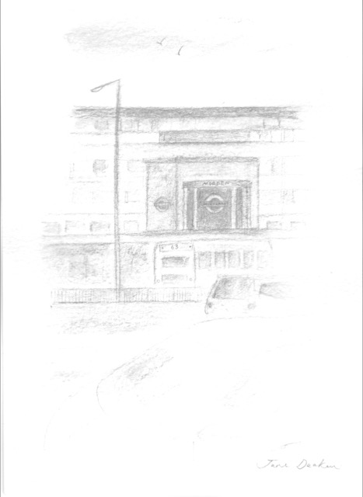

**Morden**

At the southernmost point of the Northern line

lies a fabled place which few men find.

Many a tales of its splendour be told;

some say it’s streets be paved in gold

whilst others say that all be rot,

thus many a brawl doth be begot.

So on a fair and pleasant morn

I set off to this Mor of Don

upon the nearest ‘via Bank’ train

to find this land of mythic strain,

leaving my humble home behind,

hoping my fortune there to find.

After muche toil, I reached my queste,

and I must admit, I was welle impressed

by pound shops and kebabs galore,

a Lidl, Iceland and what’s more

a hallowed Sainsbury’s did I spye!

A welcome sight to weary traveller’s eye.

Now free of worry and of care

and munching upon a chocolate eclair

I tooketh sights of this fair town

which I heard spake of in high renown.

Fast chariots I longed to see

blazoned 157 and 93.

Yet gazed upon in reality

said chariots were mainly… stationary.

Their drivers clad in visage blue

did not appear in haste to move

their chariots forth to mysterious crags

and 'stead quothed tea and smoketh fags.

I looked to heaven and asked The Lord

why I had ‘ere headed south of Norwood.

But as I raised up mine eyes,

a thing of terror filled the skies.

A monstrous block of 1960s woe

did tower over citizens below.

‘Alack!’ Cried I. ‘Poor Morden town!’

(With swift travel networks to Wimbledon.)

That hatheth much to speak its name

in handy bus station and close tube train,

to be accursed by such folly!

Is not there hope to this sad story?’

But sadly not one heard my cry

and 'stead strange looks receiveth I.

So swiftly legged I up to tube

to ‘Topeth Up’ my Oyster Blue,

and jumpeth upon the firsteth train,

never to return to Morden again.

**The poets’ garden**

Pope and Tennyson sat on the lawn,

talking of grand things

like love,

the local railway system,

and whether if you put a butterfly into a blender,

you’d get any butter out of it.

Pope said two vats. Tennyson, none.

Just then Coleridge came in, smoking a joint,

and made a pass at Woolf,

who was watching two blackbirds

tearing each other’s throats out.

‘Look at the blood,’ she said. ‘Like jam.

Perhaps I am jam.’

‘It’s blood,’ said Hughes. ‘For God’s sake it’s blood!’

Then pinned a crow to a wall

and called it Death.

Plath called him a fascist bastard

and clobbered him over the head

with a copy of *The Female Eunuch*.

‘This is fun,’ she said.

‘It’s a shame Carol Ann Duffy couldn’t come.

She’d really enjoy this.’

Shakespeare sighed and plucked at roses.

‘Look at them all,’ he said to Donne, ‘like kids.’

But Donne was too busy chatting up Dickinson,

telling her he liked her dashes,

and since they were so obviously phallic

and penetrated language,

would she like to sleep with him?

Shakespeare shook his head. He turned to Milton,

‘Is this what art’s coming to?’ he said.

‘Where’s their soul? Where’s the rhythm?

And don’t get me started on “post-modernism”!’

You see, it’s not you and me that’s out of touch-

we called shit, shit, back in our day,

we didn’t dress it up.

Because in the end, when you strip it all back,

crack open the metaphors,

ditch the bloody free verse and make the bastards

rhyme in iambic pentameter,

what do you find?

Nothing! And why? Because nothing’s there!

There’s not a single drop of genius anywhere, and that

bloody Williams is eating my plums again!’

But Milton didn’t hear.

He was too busy trying to strangle Chaucer,

who’d stolen his stick.

Shakespeare dropped his rose.

‘Fuck it,’ he said, ‘I’m going to bed.

I only came here for the booze and the sex,

and this lot are mingers.’

So he left. Which was a shame,

because just then the late Romantics turned up

and they’d bought the stripper.

### Product Details

**ISBN 9781911232094**

**Copyright Amy Deakin (Standard Copyright Licence)**

**Edition first edition**

**Publisher William Cornelius Harris Publishing**

**Published 2nd Sept 2017**

**Language English**

**Pages 44**

**Binding Perfect-bound Paperback**

**Interior Ink Black & white**

**Weight 0.11 kg**

**Dimensions (centimetres) 14.81 wide x 20.98 tall**